Finding Choice Magazine Online

- From our home page go to More than Books tab and click Online Databases
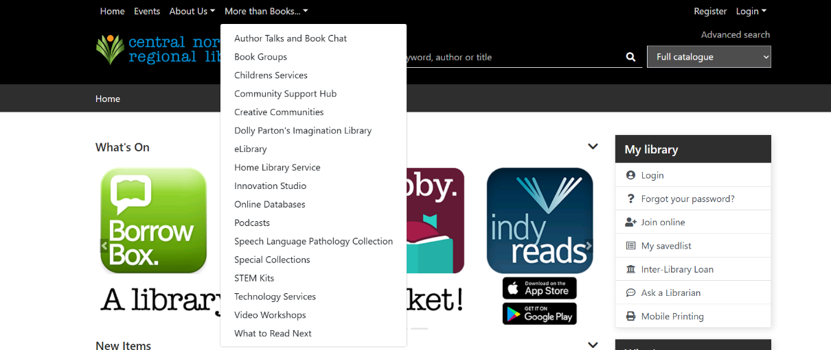

- Click on GALE: Australia & New Zealand OneFile Periodicals
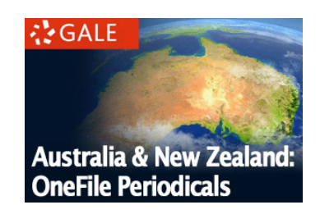

- Login with your library card number – no password needed

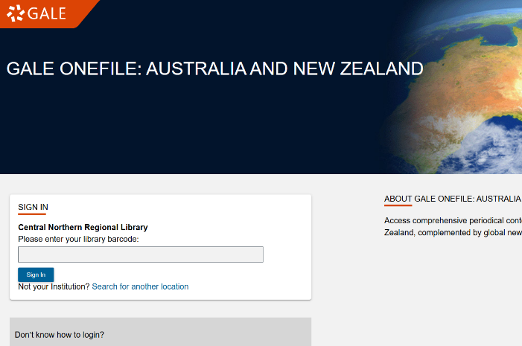
- Search for CHOICE in the Publication Search tab
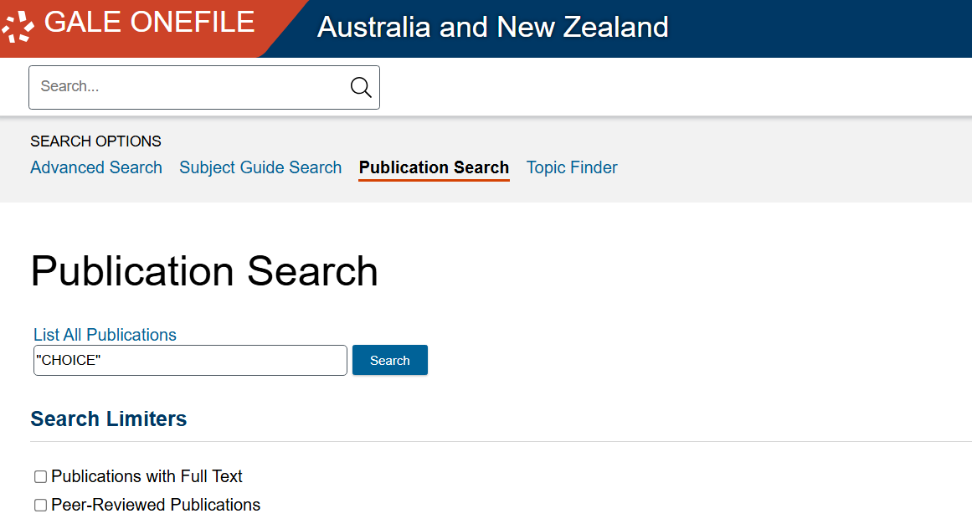

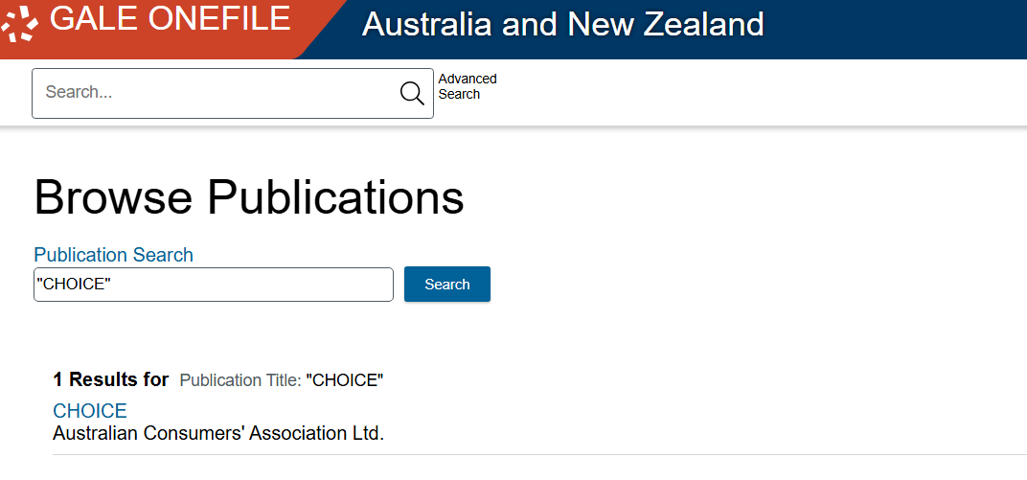
- Click on title

- Choose your year and select and issue month
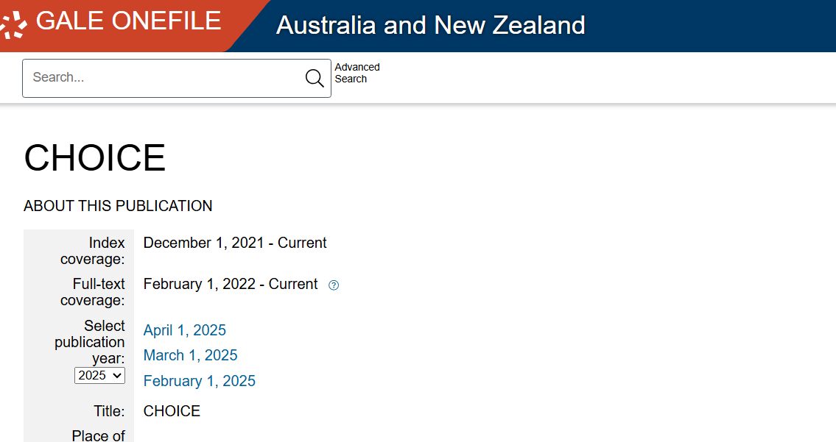

- Browse the articles from the issue and click on a title to read it
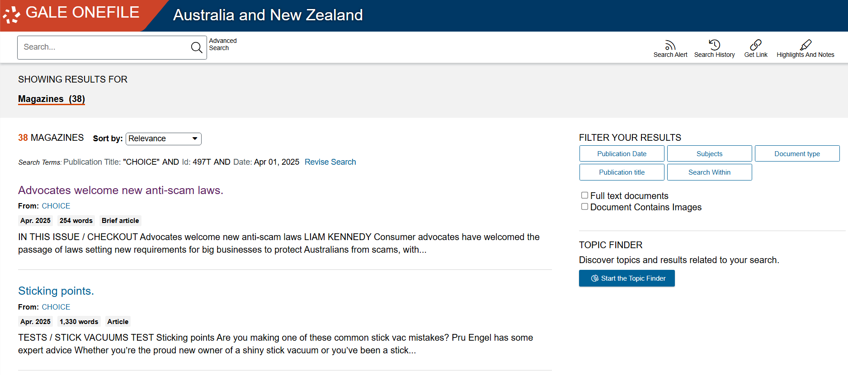

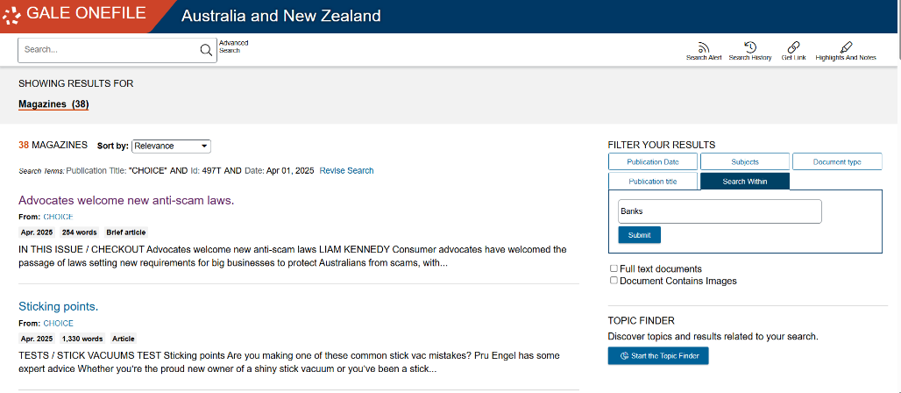
- Select search within to run a keyword search withing this issue of choice

